**CUSTOM BOOTCAMP**

**Azure Data Factory**

**CREATING SQL SERVER**

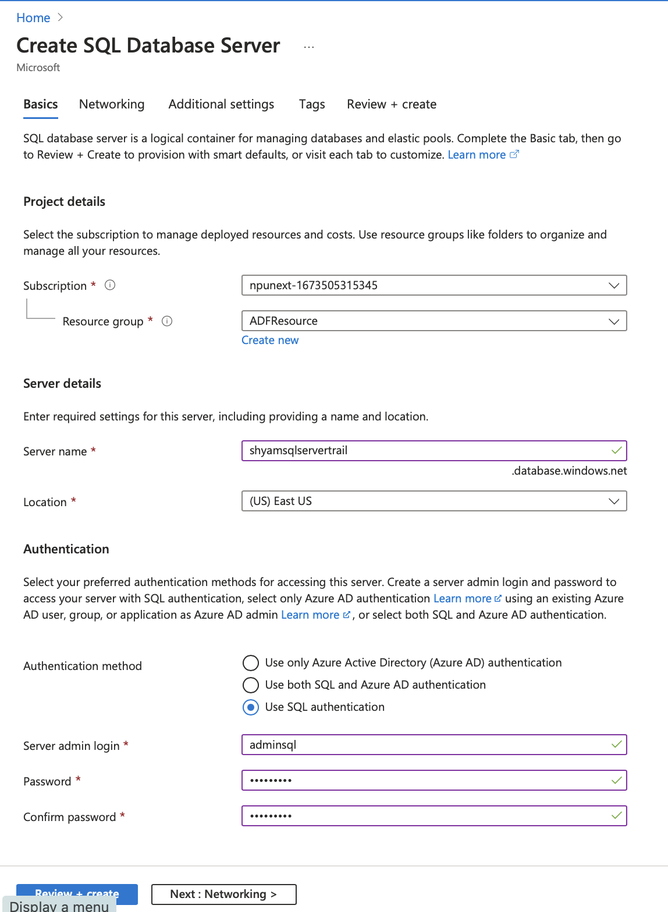

**CREATING SQL DATABASE**

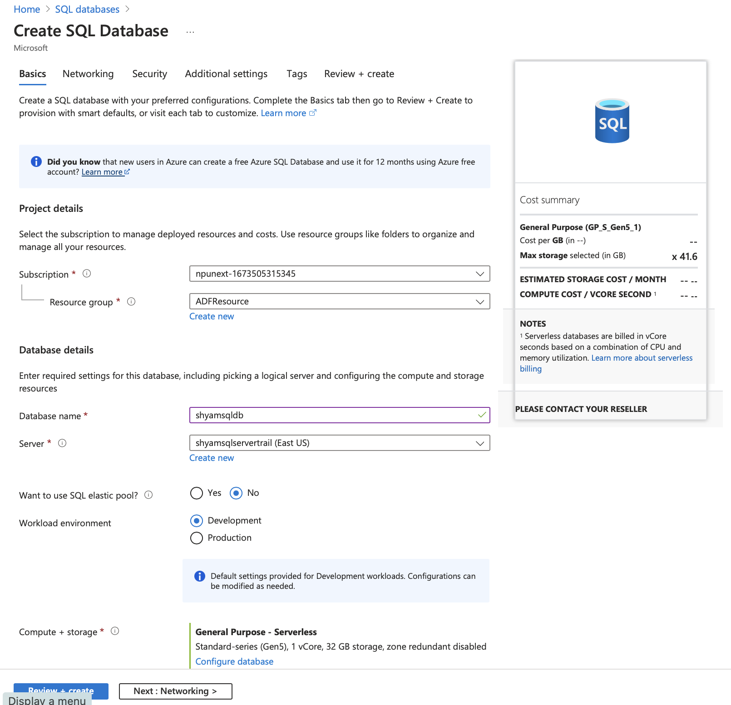

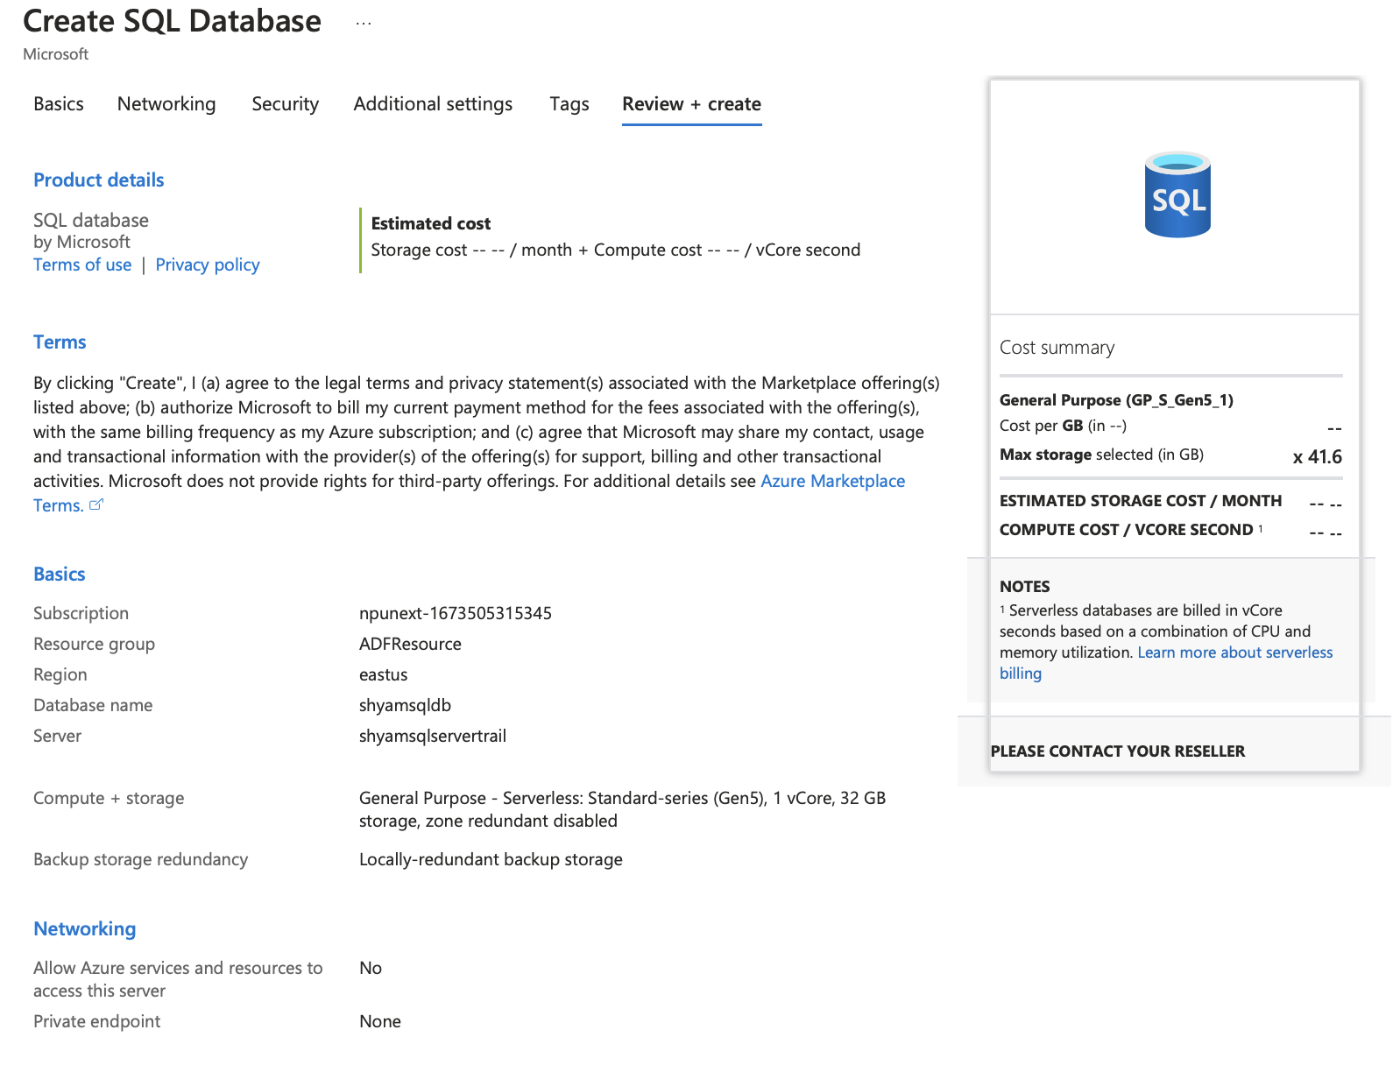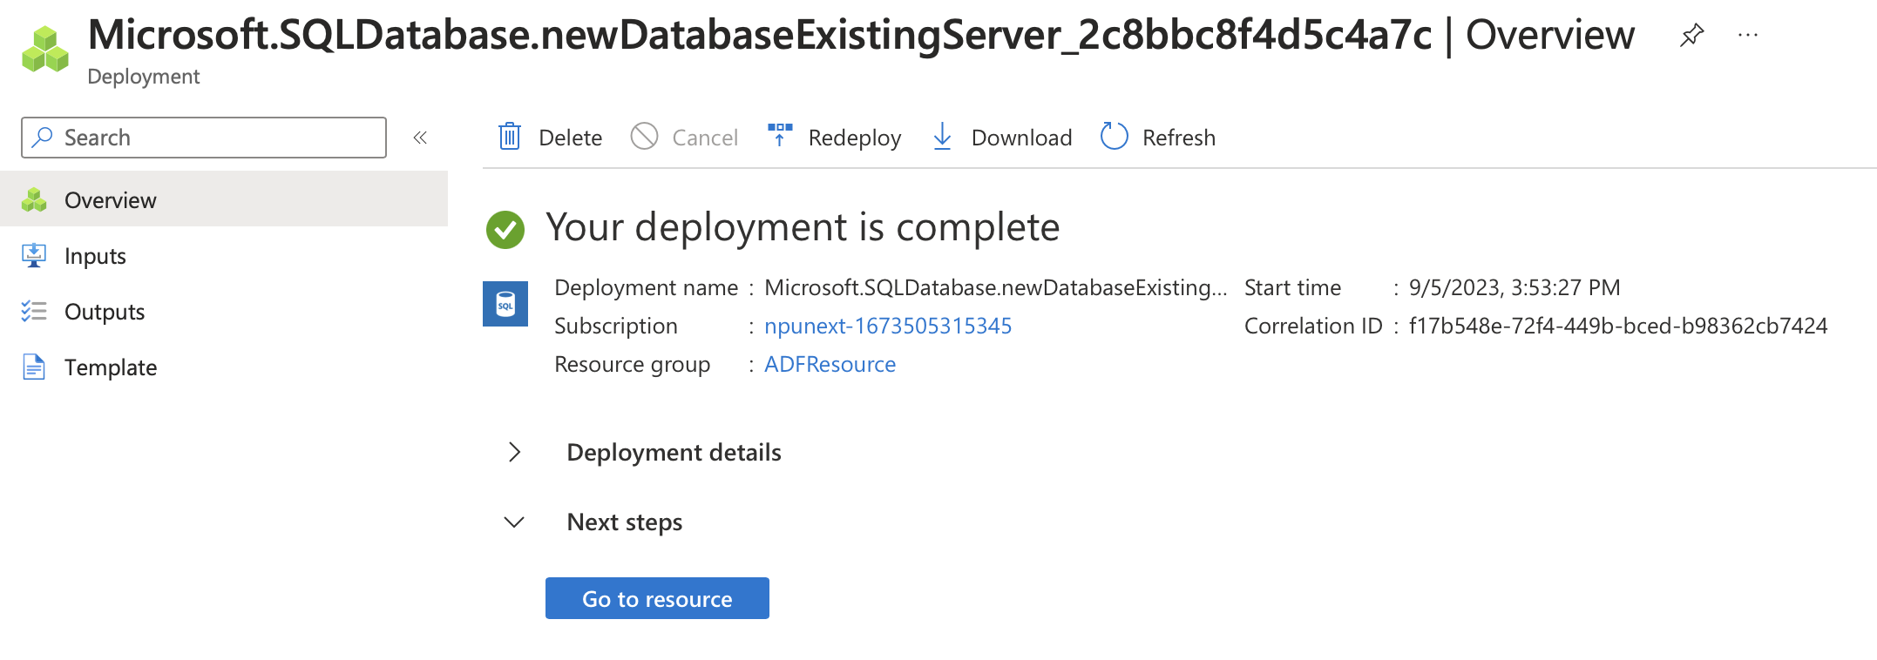

**USING QUERY EDITOR**

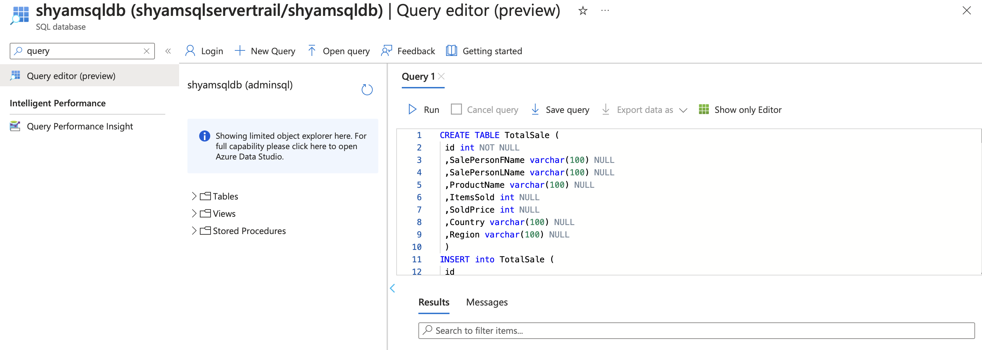

** 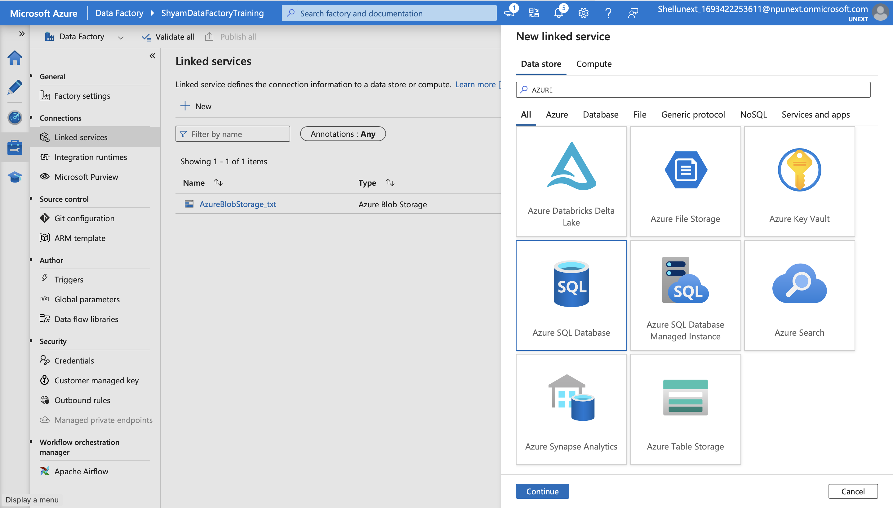

**CREATING DATASET**

**COPYING DATA FROM ONE CONTAINER TO OTHER**

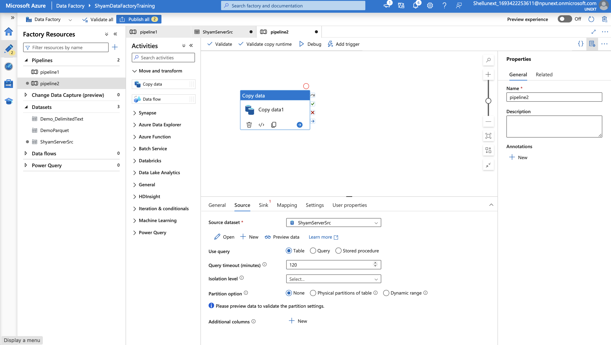

**FILLER ACTIVITY**

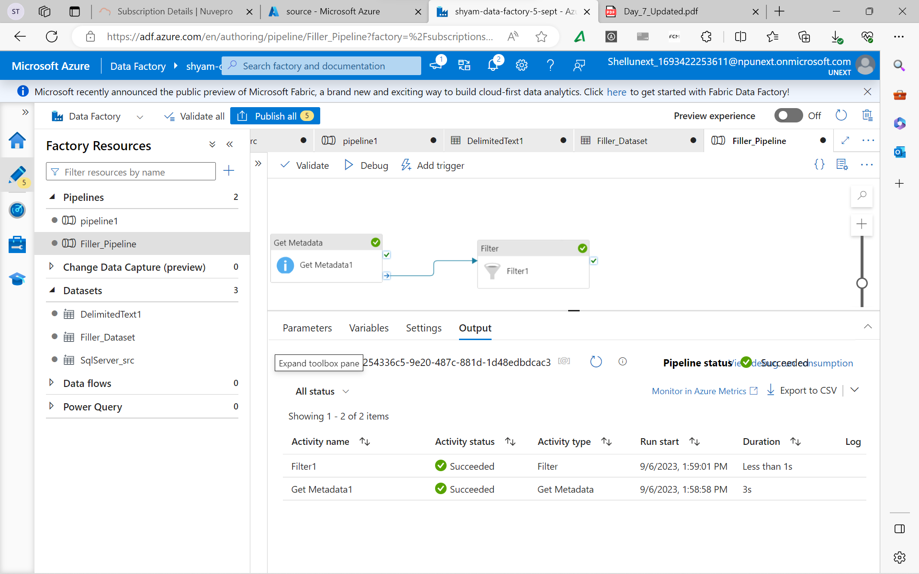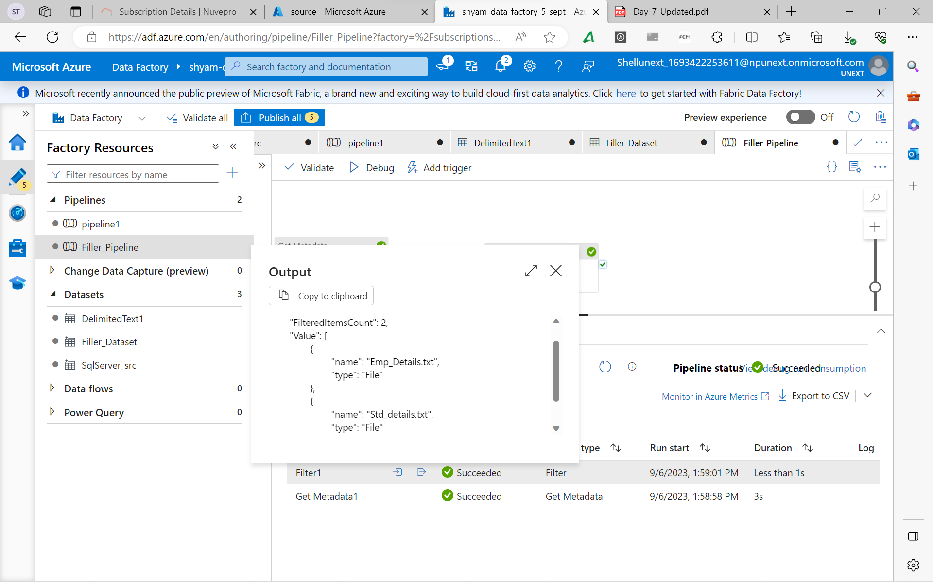

**SET VARIABLE ACTIVITY**

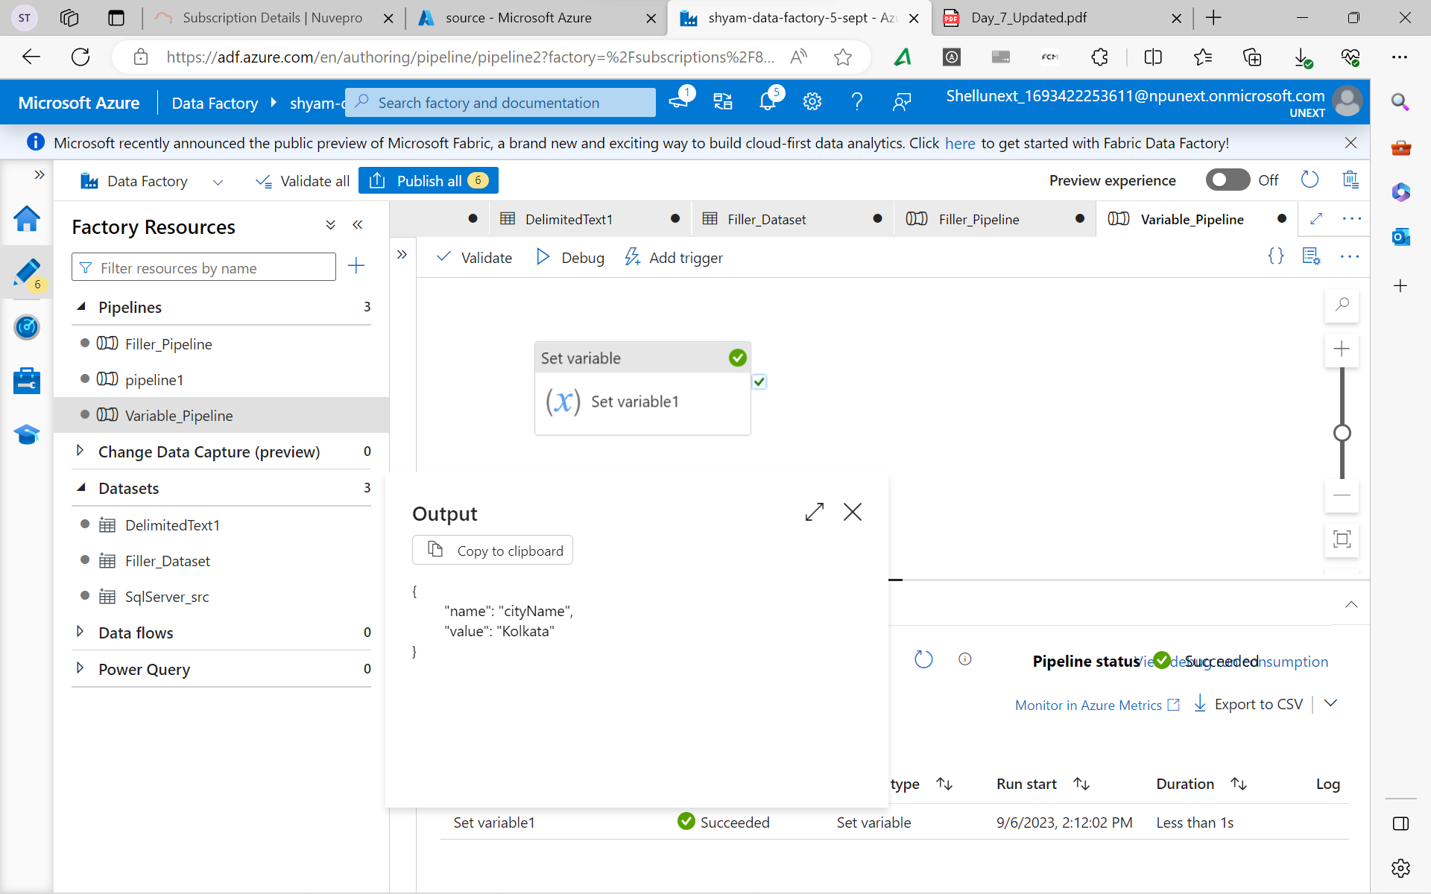

**APPEND ACTIVITY**

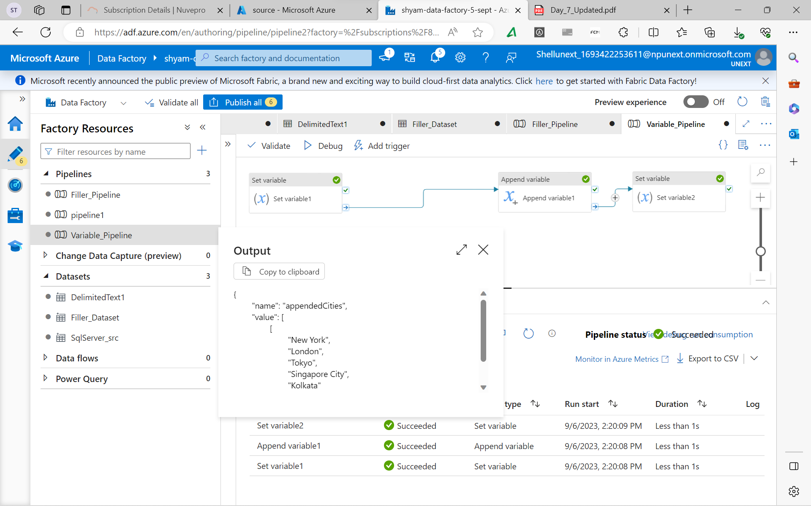

**WEB ACTIVITY**

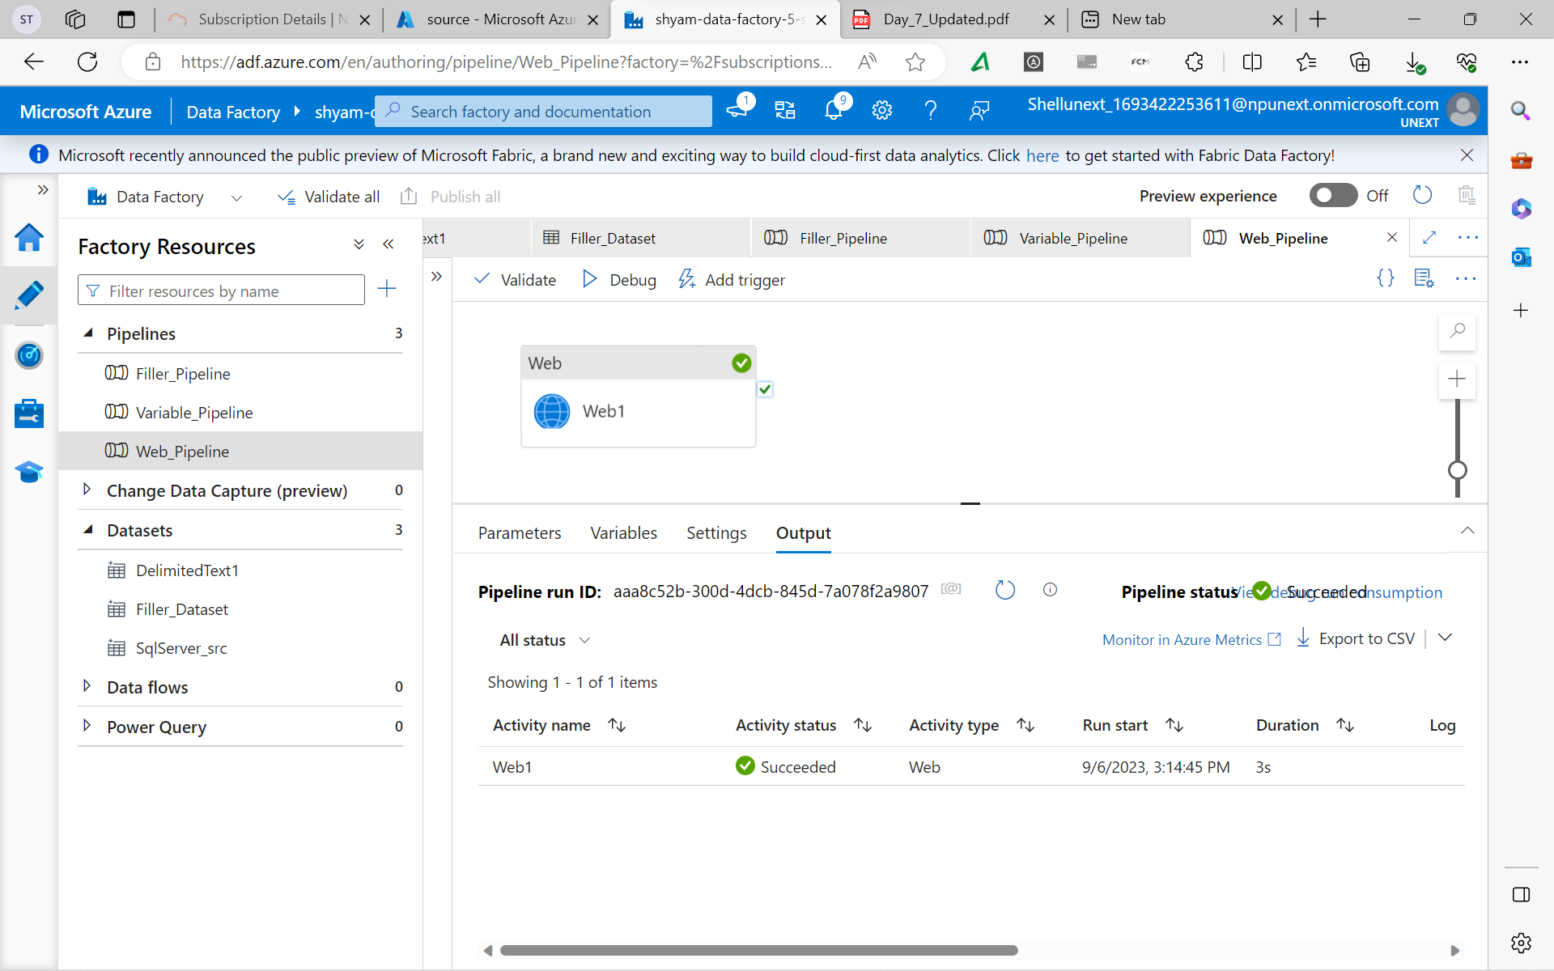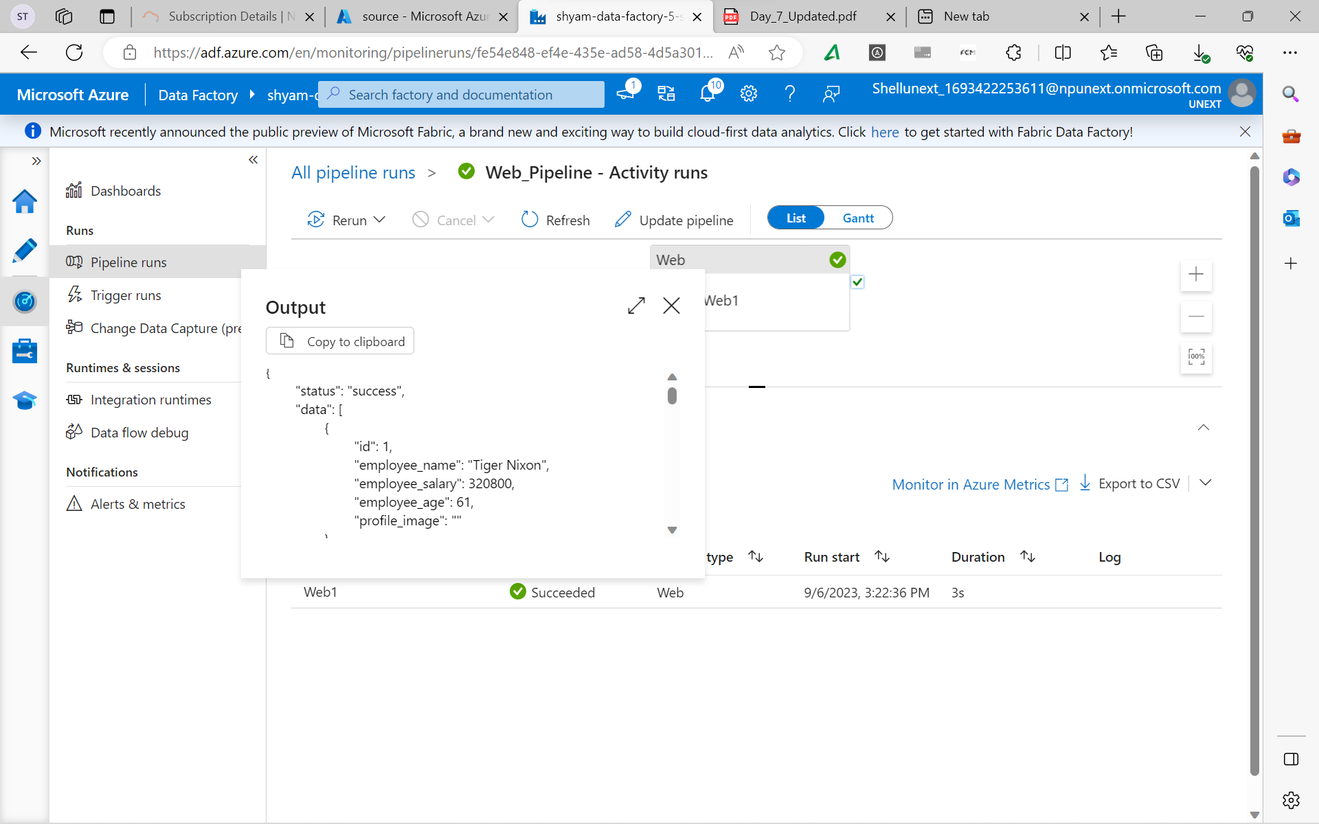

**SWITCH ACTIVITY**

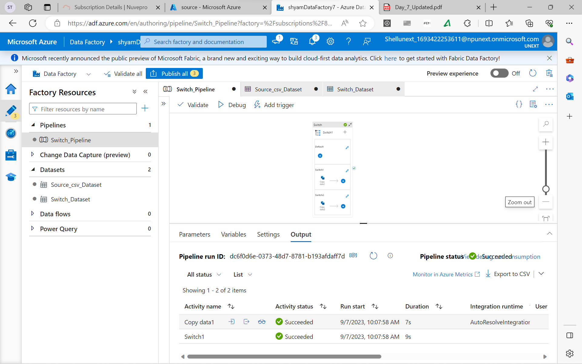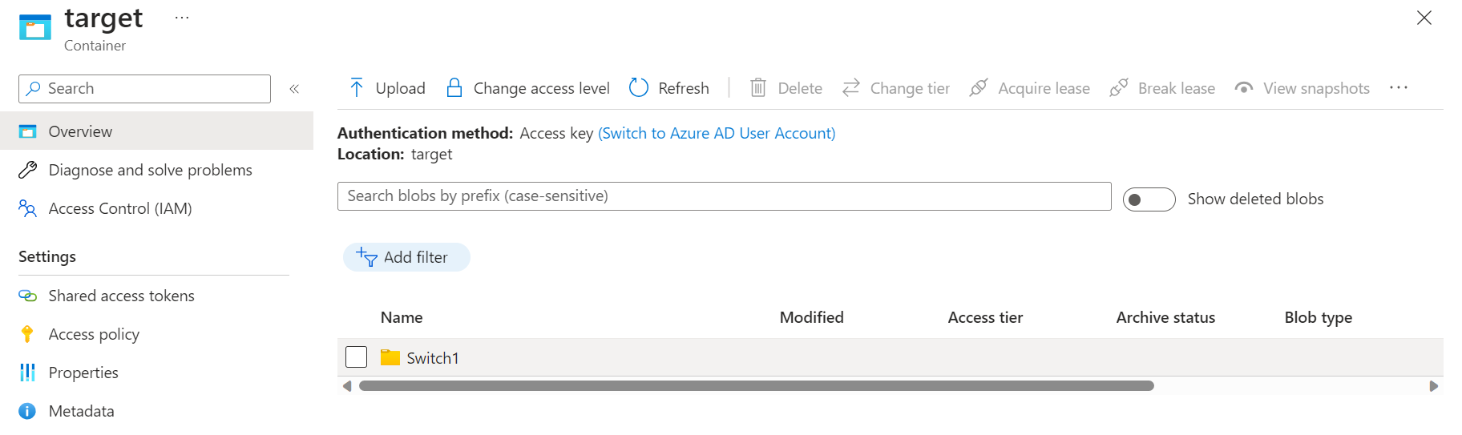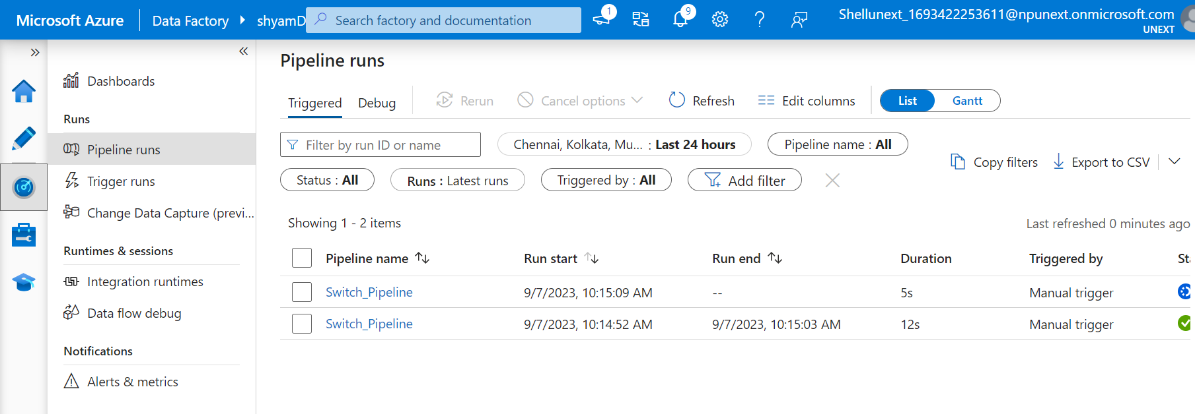

**WAIT ACTIVITY**

